**Database Management Systems**

**Course code: CS/AI 3103**

**Assignment -6**

**Note: In this assignment along with question the desired output is given if you are not getting the desired output then your sql query might be wrong. Check the output you get with the desired output.**

**Instructions to open mysql and using created database**

1. **Start mysql using**

$ mysql -u root –p

(enter password if prompted)

1. **Use database inside which you have created and store the tables given in the assignment-1**

use studentdb;

1. **Use the following employee table of assignment 4 to solve this assignment**

Employee(empid, empname, department, salary, bonus, hiredate date, currentdate date, EDOB date);

|  |  |  |  |  |  |  |  |
| --- | --- | --- | --- | --- | --- | --- | --- |
| **empid** | **empname** | **department** | **salary** | **bonus** | **hiredate** | **currentdate** | **EDOB** |
| 1 | Mark | HR | 30000 | 6000 | 2008-09-21 | 2022-10-03 | 1990-01-02 |
| 2 | Miraj | Admin | 25000 | 5000 | 2019-10-02 | 2022-10-03 | 1982-10-17 |
| 3 | Chinaya | HR | 25000 | 9000 | 2008-09-21 | 2022-10-03 | 1984-03-03 |
| 4 | Dilkush | Admin | 25000 | 6000 | 2022-10-19 | 2022-10-03 | 1980-10-21 |
| 5 | Eimanual | Account | 10000 | 4000 | 2020-08-12 | 2022-10-03 | 1983-12-19 |
| 6 | Fisal | Account | 12000 | 7000 | 2008-09-21 | 2022-10-03 | 1980-05-21 |
| 7 | Girkshan | HR | 55000 | 12000 | 2015-07-05 | 2022-10-03 | 1992-09-14 |
| 8 | Milka shingh | HR | 58000 | 10000 | 2016-09-15 | 2022-10-03 | 1990-09-15 |

**Queries: Exercise on order by clause:**

**Syntax: SELECT column_name1, column_name2,…column_namen FROM table_name Order By column_name1, column_name2…, column_name n ASC/DESC;**

1. Write the sql query to select all employee from the “employee table” sorted in descending order by their salary.

Desired output:

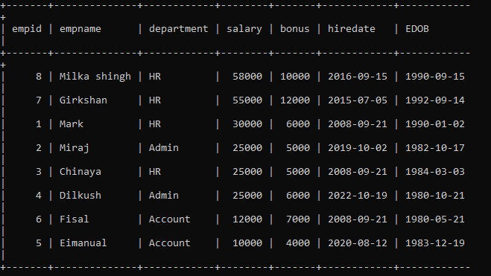

**Solution: select * from employee order by salary desc;**

1. Write the sql query to fetch the empid, empname, bonus, salary from the employee table sorted in ascending order as per their bonus and salary.

Desired output:

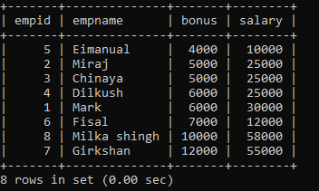

**Solution: select empid, empname, bonus, salary from employee order by bonus, salary ASC;**

1. Write the sql query to fetch all the details of employees from the employee table sorted in descending order as per their empname.

Desired output:

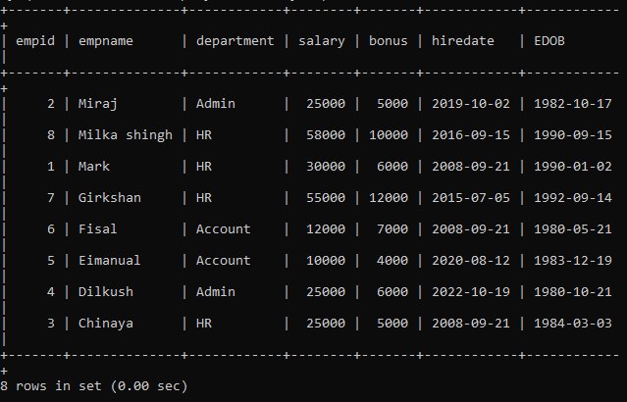

**Solution: select * from employee order by empname desc;**

**Queries: Exercise on group by and order by clause:**

**Syntax: SELECT column_name1, column_name2,…column_name n, Aggregate function(column_name) from table_name where condition group by column_name 1, column_name 2,…column_name n orderby column_name1, column_name2,…column_name n;**

1. Write the sql query to retrieve the details of highest paid employee in each department.

Desired output:

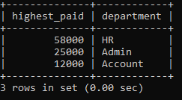

**Solution: Select max(salary) as highest_paid, department from employee group by department;**

1. Write the sql query to retrieve the details of total salary needed to pay to each department in employee table.

Desired output:

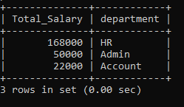

**Solution: Select sum(salary) as Total_Salary, department from employee group by department;**

1. Write the sql query to retrieve the details from the employee table of total salary needed to pay to each department sorted in ascending order by their department.

Desired output:

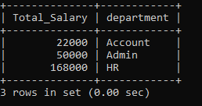

**Solution: Select sum(salary) as Total_Salary, department from employee group by department order by department asc;**

1. Write the sql query to retrieve a list of minimum salaries of all employee in each department.

Desired output:

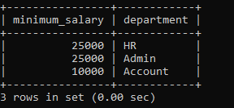

**Solution: Select min(salary) as minimum_salary, department from employee group by department;**

1. Write the sql query to retrieve a list of average salaries and count of employees in each department.

Desired output:

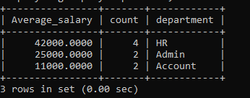

**Solution: Select avg(salary) as Average_salary, count(*) as count, department from employee group by department;**

1. Write the sql query to list the average salary and count of employee as per each employee name and department.

Desired output:

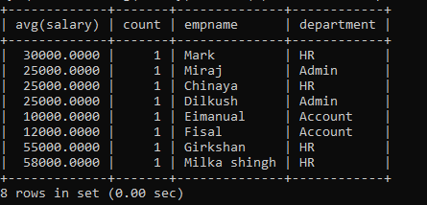

**Solution: Select avg(salary), count(*) as count, empname, department from employee group by empname, department;**

1. Write the sql query to list the average salary and count of employee as per each employee department and ename.

Desired output:

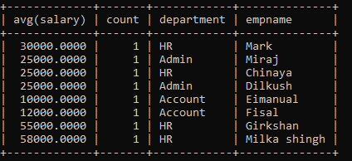

**Solution: Select avg(salary), count(*) as count, empname, department from employee group by department, empname;**

1. Write the sql query to list the average salary and count of employee in each department sorted in ascending order as per their department.

Desired output:

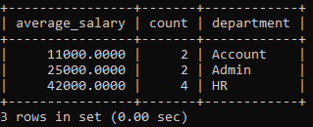

**Solution: Select avg(salary) as average_salary, count (*) as count, department from employee group by department order by department asc;**

9) Write the sql query to update the name of employee from “Milka shingh” to “Mark”

Desired output:

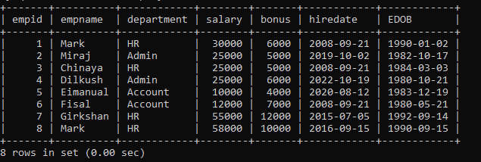

**Solution: update employee set empname='Mark' where salary=58000;**

1. Write the sql query to list the average salary and count of employee as per each employee name and department sorted in ascending order as per their employee name and department.

Desired output:

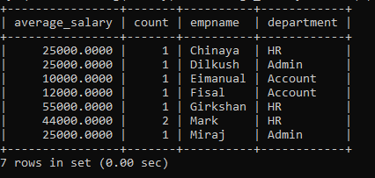

**Solution: Select avg(salary) as average_salary, count(*) as count, empname, department from employee group by empname, department order by empname, department ;**

**Queries: Exercise on group by, order by with having clause.**

**Syntax: SELECT column_name1, column_name2,…column_name n, from table_name where condition group by column_name 1, column_name 2,…column_name n having condition order by column_name 1, column_name 2,…column_name n;**

1. Write the sql query to find the maximum salary of each department from employee table but show only those department whose maximum salary is more than or equal to 50000.

Desired output:

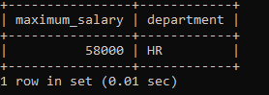

**Solution: Select department, max(salary) from employee group by department having max(salary)>=50000;**

1. Write the sql query to find the average salary of each department from employee table but show only those department whose maximum salary is less than or equal to 30000.

Desired output:

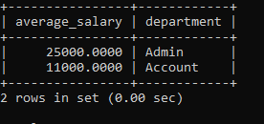

**Solution: Select department, avg(salary) from employee group by department having max(salary)<=30000;**

1. Write the sql query to find the department and total salary of all employees for each department but show only those department whose total salary is greater than 80000 and sorted in ascending order as per their total salary.

Desired output:

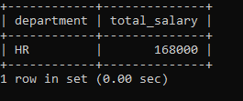

**Solution: Select department, sum(salary) as total_salary from employee group by department having sum(salary)>80000 order by sum(salary) asc;**

1. Write the sql query to display the employee name and hire date on which at least 2 employees where hired.

Desired output:

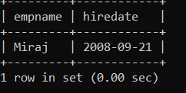

**Solution: select empname, hiredate from employee group by hiredate having count(HIREDATE)>=2;**

1. Write the sql query to display the total salary and the department name in which more than 3 employees works and the total amount required to pay the monthly salaries of all employees in that department should be more than 150,000

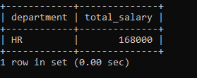

**Solution: select sum(salary), department from employee group by department having count(*)>3 and sum(salary)>150000;**